**Is collagen quantity and properties involved in wrinkle formation and follicle development ?**

**Histology of wrinkles in Merino sheep: Role of collagen in wrinkle formation.**

**Just a suggestion. You decide**

**Abstract**

**Introduction**

Most Merino sheep have wrinkly skins. Wrinkles are raised and often hardened areas of skin, presumably the consequence of excessive collagen deposition. The early Spanish Merinos from which all the fine wool breeds have descended (Randall, 1863) had wrinkly skins.

Are you sure early Merinos were wrinkled?

There has been a long and often heated debate in the Merino sheep breed-

ing community in Australia about the merits of wrinkles or folds in the skin. Starting

with Belschner (1937) who showed that skin wrinkle predisposes sheep to fly strike, the debate was taken up by geneticists who set about declaring that wrinkle was a component of clean fleece weight and establishing a scoring method with photographic standards (Carter, 1943; Turner et al,1953; Turner, 1956; and Turner, 1958).

Two selection experiments, for and against wrinkle, were started, one by the New South Wales Department of Agriculture, called Folds Plus and Folds Minus lines (Dun,1964) and one by CSIRO, called the Wrinkle Plus, and Wrinkle Minus lines (Turner et al, 1970). The geneticists concluded that there was a possibility that selection for fleece weight would increase wrinkle, and recommended that some culling against wrinkle be conducted in association with selection for fleece weight. There were also negative implications of wrinkle for fertility (Dun, 1964; Dun and Hamilton, 1965; and Drinan and Dun, 1965).

On the other hand, one of the authors (JW) has developed a Merino sheep with a loose and supple skin, completely free of skin wrinkle. He asserts that this skin type is necessary to produce fleeces of high quantity and quality (Watts et al, 2017), with the sheep being naturally resistant to fly strike and not requiring to be mulesed (Watts, 2008 a, b; Watts, 2016). The skin type, referred to as SRS, consists of orderly rows of compact follicle groups with a high secondary follicle to primary follicle (S/P) ratio due to compound follicles having more branches, and fine and long primary and secondary fibres which are softer than normal wool. The question arises as to why it is necessary for the skin to be wrinkle-free ?

Jackson and Watts (2017) put forward the hypothesis that because wrinkles form in the foetus at the same stage as secondary follicle development, wrinkles would be likely to affect secondary follicle density or secondary follicle to primary follicle (S/P) ratio or secondary fibre diameter. This was based on a somewhat obscure reference (Bogolyubsky, 1940) which asserts that wrinkles were observed forming in the foetal skin of Merino and Karakul lambs at around 100 days of gestation, first on the dorsal surface and then extending down the sides to the belly.

What is proposed here is that the location, amount and type (and maybe timing and arrangement) of collagen development in the skin might be a common factor with both wrinkle development and follicle development.

….. might be a factor in wrinkle development, and might also influence some aspects of follicle development. It is also proposed that the amount of follicle development seen in Merino sheep might be a predisposing factor in wrinkle development.

So what is known about collagen? It is the major component of connective tissue (elastin and reticulin are minor components). Collagen is already there in the foetal sheep skin at 75 to 80 days; the time when wool follicles develop (Knight et al 1993). These authors distinguish two collagen types (Type III or ‘soft collagen’, and Type I or ‘hard’ collagen) and note that Type III is highest at 75 days of gestation, and falls progressively as the foetus develops, while Type I is low at day 75 and rises to over 50 percent by birth. Collagen fibres are formed from cells called fibroblasts. At 75 to 80 days the fibroblasts appear as plump, immature cells surrounded by reticular collagen fibres which are composed of Type III collagen. By birth the fibroblasts have matured and the collagen fibres may be enmeshed to varying degrees. If the fine, reticular fibre pattern remains, it is soft collagen. If the fibres enmesh the collagen tissue is hardened to various degrees.

The skin of Merino sheep consists of five layers which can be distinguished by eye and histologically (Figure 1). These layers are known as the epidermis (layer 1), papillary dermis (layer 2), reticular dermis (layer 3), areolar tissue with muscle (layer 4) and adipose tissue (layer 5). The papillary layer contains wool follicles and accessory glands and most of the collagen. The papillary layer can be subdivided into the follicular dermis and subfollicular dermis, which are of similar thicknesses.

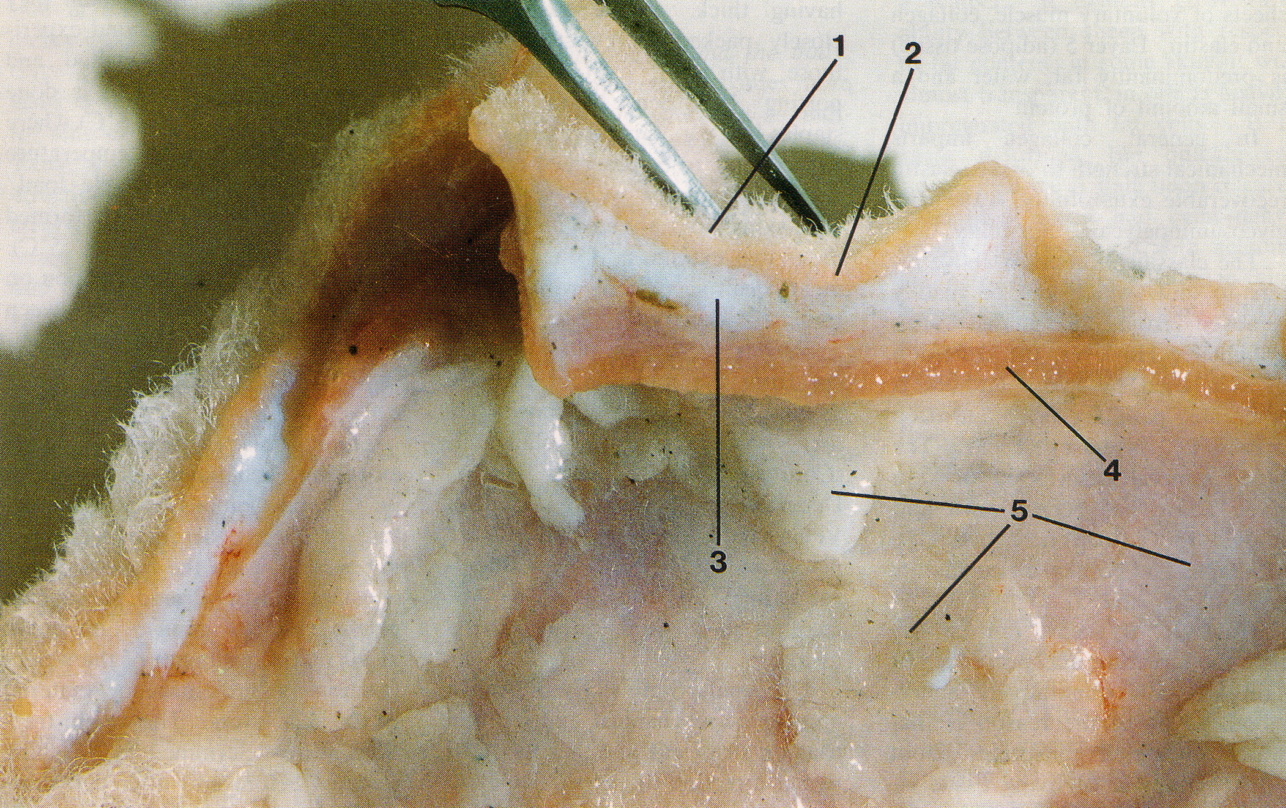

**Figure 1. Merino sheep skin showing layers. 1. epidermis with wool fibres; 2. papillary layer of dermis, 3. reticular layer of dermis; 4. areolar tissue and muscle; and 5. adipose tissue. Two wrinkles are present; one alongside each side of the forceps (modified from Mitchell et al, 1984).**

Histologically, these layers are seen again in Figure 2.

(Sanaz, please recut sample #3456,H & E/PSR for 4 layer photo here, and annotate layers in Figure 1).

**Figure 2. Vertical section of Merino sheep skin at low magnification (x 4) showing 5 layers. H & E/PSR.**

When wrinkles occur in the skin (see Figure 1), the epidermis, papillary dermis and reticular dermis buckle up into a fold, while the underlying areolar/muscle layer and adipose tissue layer remain straight. It appears as if wrinkles are formed either by an overgrowth of layer 2, or by a shrinkage or tightening of layer 4, or both.

Mitchell (1984) showed that if layer 4 (and layer 5) are dissected away from a skin specimen with wrinkles, the folds in layers 1 to 3 flatten out. In a wrinkled sheep, layer 4 is holding the skin under some tension, which relaxes when layer 4 is removed. Nevertheless, the published photograph of Mitchell’s dissection (Figure 5) reveals that the wrinkles are not completely removed.

Wrinkles mostly form in rows. Hence, collagen development must be in one dimension.

Maybe the one-dimensional nature of wrinkles comes from the one-dimensional nature of follicle groups. The direction of rows of follicle groups corresponds to the prevailing direction of wrinkles – ie dorsal to ventral on the body.

If it were two dimensional the upper 3 layers of skin would form a lump, rather than a fold. There is no reported observation of directional unevenness of collagen, but it must be so, or we would get lumps rather than folds.

We need to also ask if there are links between collagen development and follicle development.

**Materials and Methods**

**Sheep studied**

Merino sheep were studied. Two trials were conducted. Details are shown in Table 1.

Table 1.

|  |  |  |  |  |
| --- | --- | --- | --- | --- |
| Trial | Flock | Age of sheep (months) | Sex of sheep | Number of sheep |
| 1 | 1 |  | rams | 2 |
|  | 2 |  | rams | 2 |
|  | 3 |  | rams | 2 |
|  | 5 |  | rams | 2 |
|  | 6 |  | rams | 2 |
|  |  |  |  |  |
| 2 | Glensloy |  | ewes | 18 |
|  | Manton |  | ewes | 18 |

In trial 1, a loose skin sheep was compared to a wrinkly skin sheep from 5 Merino flocks. The skin samples had been trimmed so that only layer 1 (epidermis) and layer 2 (papillary dermis) were available for histological observation and measurement.

In trial 2, 9 sheep with loose skins were compared with 9 sheep with wrinkly skins, in each of 2 flocks. Wrinkle development was more accentuated in the Manton sheep than in the Glensloy sheep. For the sheep with wrinkly skins, measurements and scores were made for skin samples collected from on the wrinkles as well as between the wrinkles. The skin samples included layers 1 to 4. Histological observations were carried out on all layers.

**Gross examination**

Midside skin samples were collected using a 10 millimetre circular trephine (Acu Punch® skin biopsy punches, Acuderm, Inc.) and fixed in 10% formol saline solution.

You have to make an animal ethics statement here.

Skin samples were washed in several changes of water, the wool stubble trimmed and then examined under a magnifying lamp ( x …. magnification). Scores for suppleness (1 = hardened to 5 = supple) of the papillary layer and reticular layer were made. Careful examination was undertaken to determine if the skin layers, layer 2 and 3, and layers 3 and 4, were free or fixed and whether localized hardening and folding of the skin had occurred.

The thickness of the papillary dermis and the reticular dermis were measured using a ruler graduated in one millimetre divisions. A Mitutoyo ballpoint gauge (model …) was then used to measure the compressed skin thickness at four sites for each skin sample.

**Histology**

Vertical skin sections cut from paraffin embedded samples were stained with H & E and picrosirius red (PSR). H & E sections were used to describe the skin histology. The PSR sections were used to measure dermal collagen content using the computational analysis technique of ……. PSR sections under polarized light were examined for dermal collagen types.

(Sanaz, can you please describe the procedures for H & E, picrosirius staining, computational analysis of collagen content and polarised light examination here).

Vertical skin sections, approximately 0.3 millimetres wide, were cut freehand with a sharp razor blade on a freezing stage and stained with 0.25 % Nile blue sulphate, as described by Nay (1973). The sections were cut parallel with the angle of emergence of the fibres to avoid cutting through follicles. Mean follicle curvature was scored from 1 = straight follicles to 7 = tangled follicles by reference to a set of standard drawings used by Nay and Johnson (1973). Examples of low and high follicle curvature are shown in Figure 3. Follicle depth was measured as the angular distance (in millimetres) between the skin surface and the lower ends of the follicle bulbs.

(JW to insert photos here)

**Figure 3. Thick freehand vertical sections showing straight follicles, score 2, (top) and tangled follicles, score 6 (bottom). Stained with Nile blue sulphate. X 50 (reproduced from Maddocks and Jackson, 1988)**

Horizontal skin sections were prepared and measurements made as described by Maddocks and Jackson (1988) using the frozen section technique and measurement procedures of Nay (1973). The sections were used to measure follicle density, S/P ratio, primary fibre diameter and secondary fibre diameter of the sheep.

**Results**

**Trial 1**

**Skin, follicle and fibre properties**

Measurements of the thickness of the papillary layer, follicle curvature, secondary fibre diameter and standard deviation of secondary fibre diameter are shown in Table 1.

**Table 1.**

|  |  |  |  |  |  |  |  |  |
| --- | --- | --- | --- | --- | --- | --- | --- | --- |
| Flock no. | Sheep no. | Skin type | Suppleness score | TST (mm) | CST (mm) | Follicle curvature | Ds | DsSD |
| 1 | W206 | loose | 5 | 2.5 | 0.62 | 3 | 23.8 | 2.9 |
|  | W205 | wrinkly | 2 | 2.5 | 1.14 | 6 | 29.5 | 4.2 |
|  |  |  |  |  |  |  |  |  |
| 2 | W490 | loose | 5 | 2.0 | 0.72 | 4 | 22.4 | 3.5 |
|  | W479 | wrinkly | 2 | 2.3 | 1.4 | 6 | 22.6 | 3.8 |
|  |  |  |  |  |  |  |  |  |
| 3 | W555 | loose | 5 | 2.0 | 0.65 | 3 | 18.4 | 2.6 |
|  | W547 | wrinkly | 1 | 2.8 | 1.16 | 7 | 19.9 | 2.9 |
|  |  |  |  |  |  |  |  |  |
| 5 | W567 | loose | 5 | 2.0 | 0.6 | 3 | 18.6 | 1.8 |
|  | W558 | wrinkly | 2 | 2.8 | 1.02 | 3 | 21.7 | 5.3 |
|  |  |  |  |  |  |  |  |  |
| 6 | W283 | loose | 5 | 2.5 | 0.77 |  |  |  |
|  | W290 | wrinkly | 2 | 2 | 1.12 |  |  |  |

Loose skin sheep had more compressible skins than wrinkly skin sheep. In the loose skin sheep, the follicles were straighter and produced secondary wool fibres that were finer and less variable in diameter than in the wrinkly skin sheep.

**Collagen content, type and distribution**

Collagen content of the papillary layer is shown diagrammatically in Figure 3.

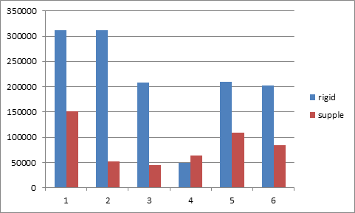

(Sanaz, please label X and Y axes, reverse columns so that supple columns precede rigid columns, delete Flock 4 columns, change “supple” to “loose” and “rigid” to “wrinkly” and provide measured values for each sheep)

**Figure 3. Collagen content of subfollicular tissue in the papillary layer of loose skin sheep and wrinkly skin Merino sheep.**

Loose skin sheep had lower collagen content than wrinkly skin sheep.

Histological images of the epidermis and the papillary dermis for each sheep are shown in Figure 4.











**Figure 4. Histological images of the epidermis and the papillary dermis of loose skins (left) and wrinkly skins (right) of Merino sheep in 5 flocks. The first image has a thin arrow showing the epithelium and a thick arrow showing the papillary dermis. PSR x 4.**

In each of the 5 sheep with wrinkly skins, there is a thick and continuous layer of collagen fibres immediately below the follicles. These collagen fibres also surround the follicle bulbs and can be found between the follicles. The follicles are highly curved and unevenly seated.

In the loose skin sheep, the thick layering of collagen fibres is absent, except for one (flock 2) of the 5 sheep. There is no heavy collagen deposition around the follicle bulbs or between the follicles, and the follicles are straight and evenly seated.

**Trial 2**

**Skin and follicle properties**

JW to describe skin lesions detected on gross examination here.

The wrinkly sheep from the Glensloy flock had many skin wrinkles running over their bodies but no obvious skin folds. The wrinkly sheep from the Manton flock had many skin wrinkles and also large folds (Figure 5).

(insert Figure 5)

**Figure 5. … Photos of Glensloy and Manton sheep**

Gross examination of the Glensloy skin samples showed layers 3 and 4 were unattached in all of the loose skin sheep and fixed in all of the wrinkly sheep.

On gross examination of the Manton skin samples showed that layers 3 and 4 were unattached in all 9 of the loose skin sheep and fixed in only 3 of the 9 wrinkly skin sheep. In the wrinkly group, wrinkled areas of skin were present in 8 of the 9 sheep and had formed by layer 3 adhering to layer 3, like interlocked vertical pillars, and not as a consequence of layer 3 binding to layer 4.

Table 2. Glensloy and Manton (9 sheep per sampling site)

|  |  |  |  |  |  |  |  |
| --- | --- | --- | --- | --- | --- | --- | --- |
| Flock | Sampling site | Papillary dermis | | | | Reticular dermis | |
| Suppleness score | TST (mm) | CST (mm) | Suppleness score | | TST  (mm) |
| Glensloy | loose skin | 3.8 | 2.7 | 0.70 | 4.3 | | 1.6 |
|  | between wrinkles | 1.9 | 3.3 | 1.89 | 3.7 | | 3.1 |
|  | on wrinkle | 2.9 | 2.8 | 1.01 | 3.3 | | 3.1 |
| Manton | loose skin | 3.5 | 3.0 | 0.90 | 4.4* | | 2.3* |
|  | between wrinkles | 2.1 | 2.9 | 1.34 | 2.9 | | 2.7 |
|  | on wrinkle | 1.9 | 2.4 | 1.11 | 2.8 | | 3.5 |

* Footnote: 18 sheep sampled

In both flocks, the papillary dermis of the loose skin sheep were more supple and compressible than the papillary dermis of the wrinkly skin sheep. The reticular dermis was also more supple and thinner in the loose skin sheep than in the wrinkly skin sheep.

**Collagen content**

Figure 6 shows the amounts of collagen measured in the papillary dermis of the Glensloy and Manton sheep.

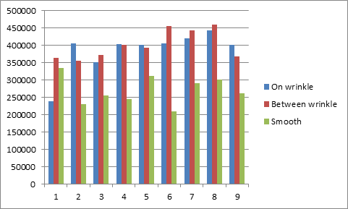

(insert Manton graph here)

**Figure 6. Collagen content of subfollicular tissue in the papillary layer of loose skin sheep and between the wrinkles and on the wrinkles of the wrinkly sheep from the Glensloy sheep (top) and Manton sheep (bottom).**

(Sanaz, please change columns in graphs to have smooth first, then between, then on wrinkle and label X and Y axes and change “smooth” to “loose”. Please send me the measured values of collagen content of each animal in Figure 2 for statistical analysis)

In the Glensloy flock, the loose skin sheep had significantly less collagen in the papillary dermis than the wrinkly sheep. There was no significant difference in collagen content of the sampling sites (“between wrinkle” and “on wrinkle”) of wrinkly sheep.

In the Manton flock, the loose skin sheep ……….

**Collagen distribution and arrangement**

As observed in Trial 1, collagen fibres were located mainly in the papillary dermis at the subfollicular level and were arranged as sheets (Figure 7). There were only isolated collagen fibres found in the reticular dermis (layer 3) and the areolar tissue and muscle layer (layer 4).



Figure 7. Collagen fibres, arranged as sheets, are concentrated in the sub follicular layer (arrow) of the papillary dermis. Immediately above this layer, the follicle bulbs (arrows) can be seen. H & E x 10.

The collagen sheets were more numerous, wider and more enmeshed in the wrinkly sheep than in the loose skin sheep (Figure 8; see Table 3).



3455 between wrinkle 10 x jpg

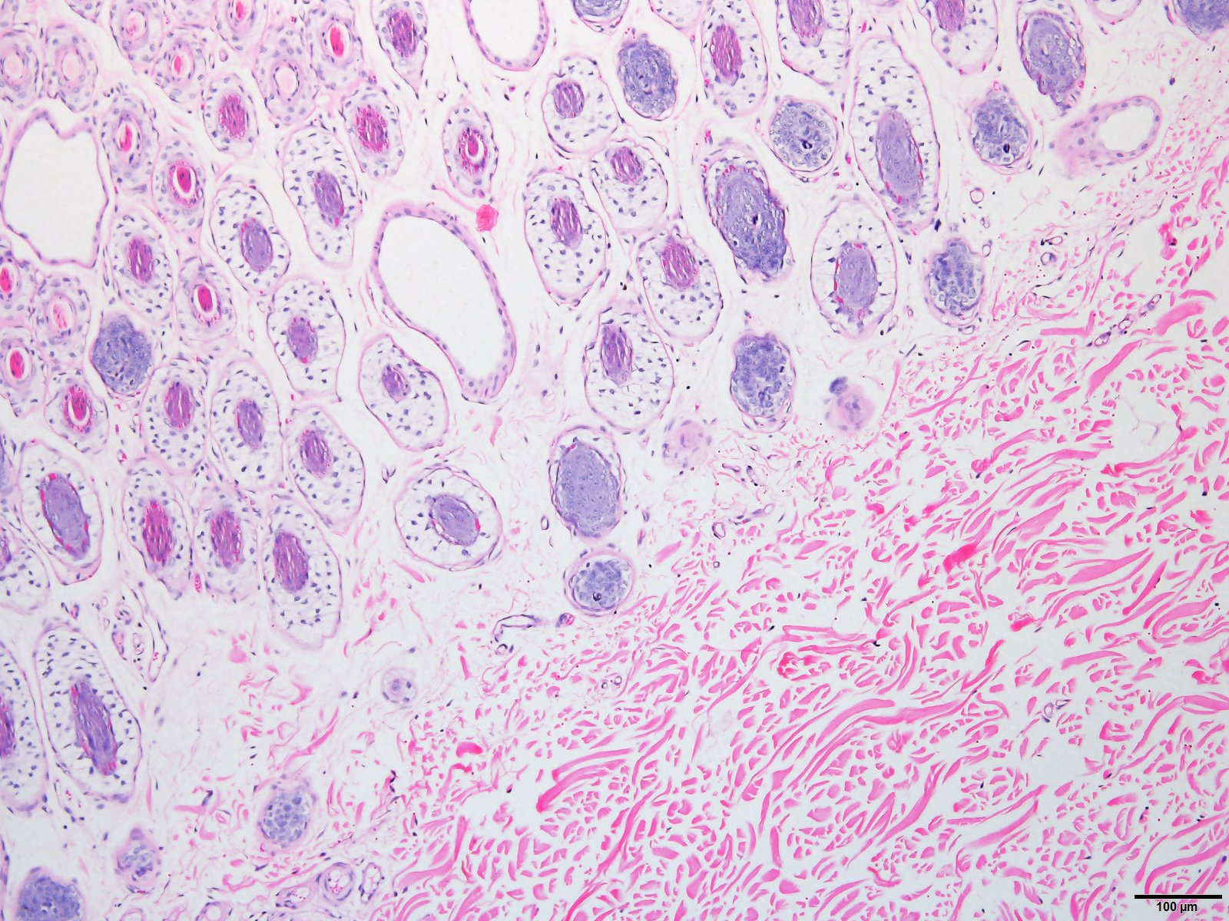

**Figure 8. Wrinkly skin sheep (top;** 3455 between wrinkle 10 x jpg**) and loose skin sheep (bottom;** 3464 smooth 10 x H & E jpg**)**

Table 3. The width, length and orientation of collagen sheets in loose skin and wrinkly sheep (JW to complete measurements).

|  |  |  |  |  |
| --- | --- | --- | --- | --- |
| Flock | Skin type | Collagen sheet | | |
| Width (microns) | Length (microns) | Orientation |
| Glensloy | Loose |  |  |  |
|  | Between wrinkles |  |  |  |
|  | On wrinkles |  |  |  |
| Manton | Loose |  |  |  |
|  | Between wrinkles |  |  |  |
|  | On wrinkles |  |  |  |

Collagen sheets were present in the follicular layer of the papillary dermis

of wrinkly sheep. The sheets were found in great numbers surrounding the follicle bulbs. The follicle bulbs were randomly orientated (Figure 9).

In the loose skin sheep, collagen sheets were restricted to the subfollicular layer of the papillary dermis. There was no infiltration of collagen sheets into the follicular layer seen. The follicles were highly aligned.

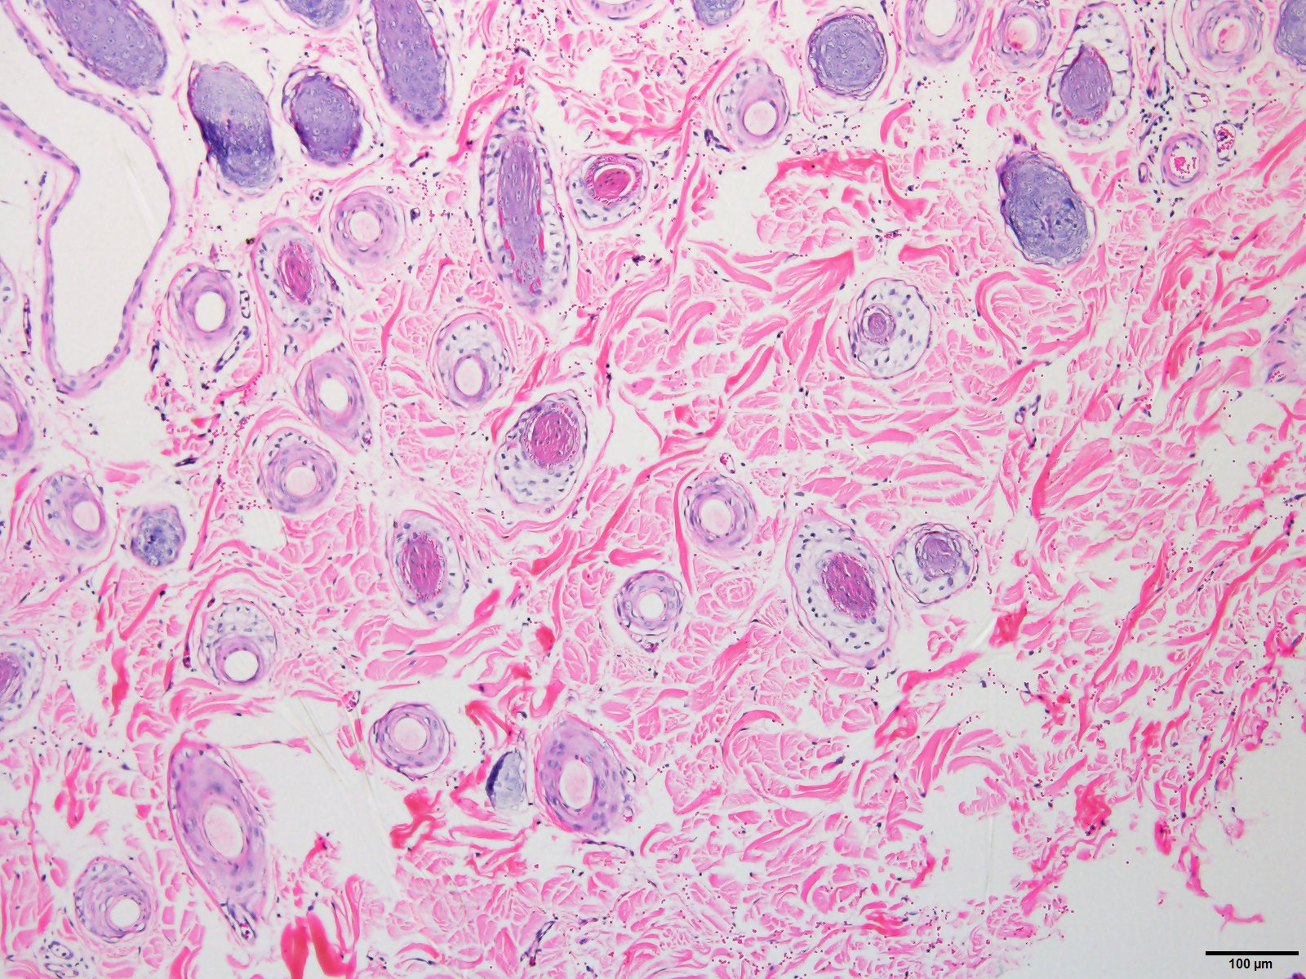

3453 between wrinkles 10 x jpg , follicle displacement

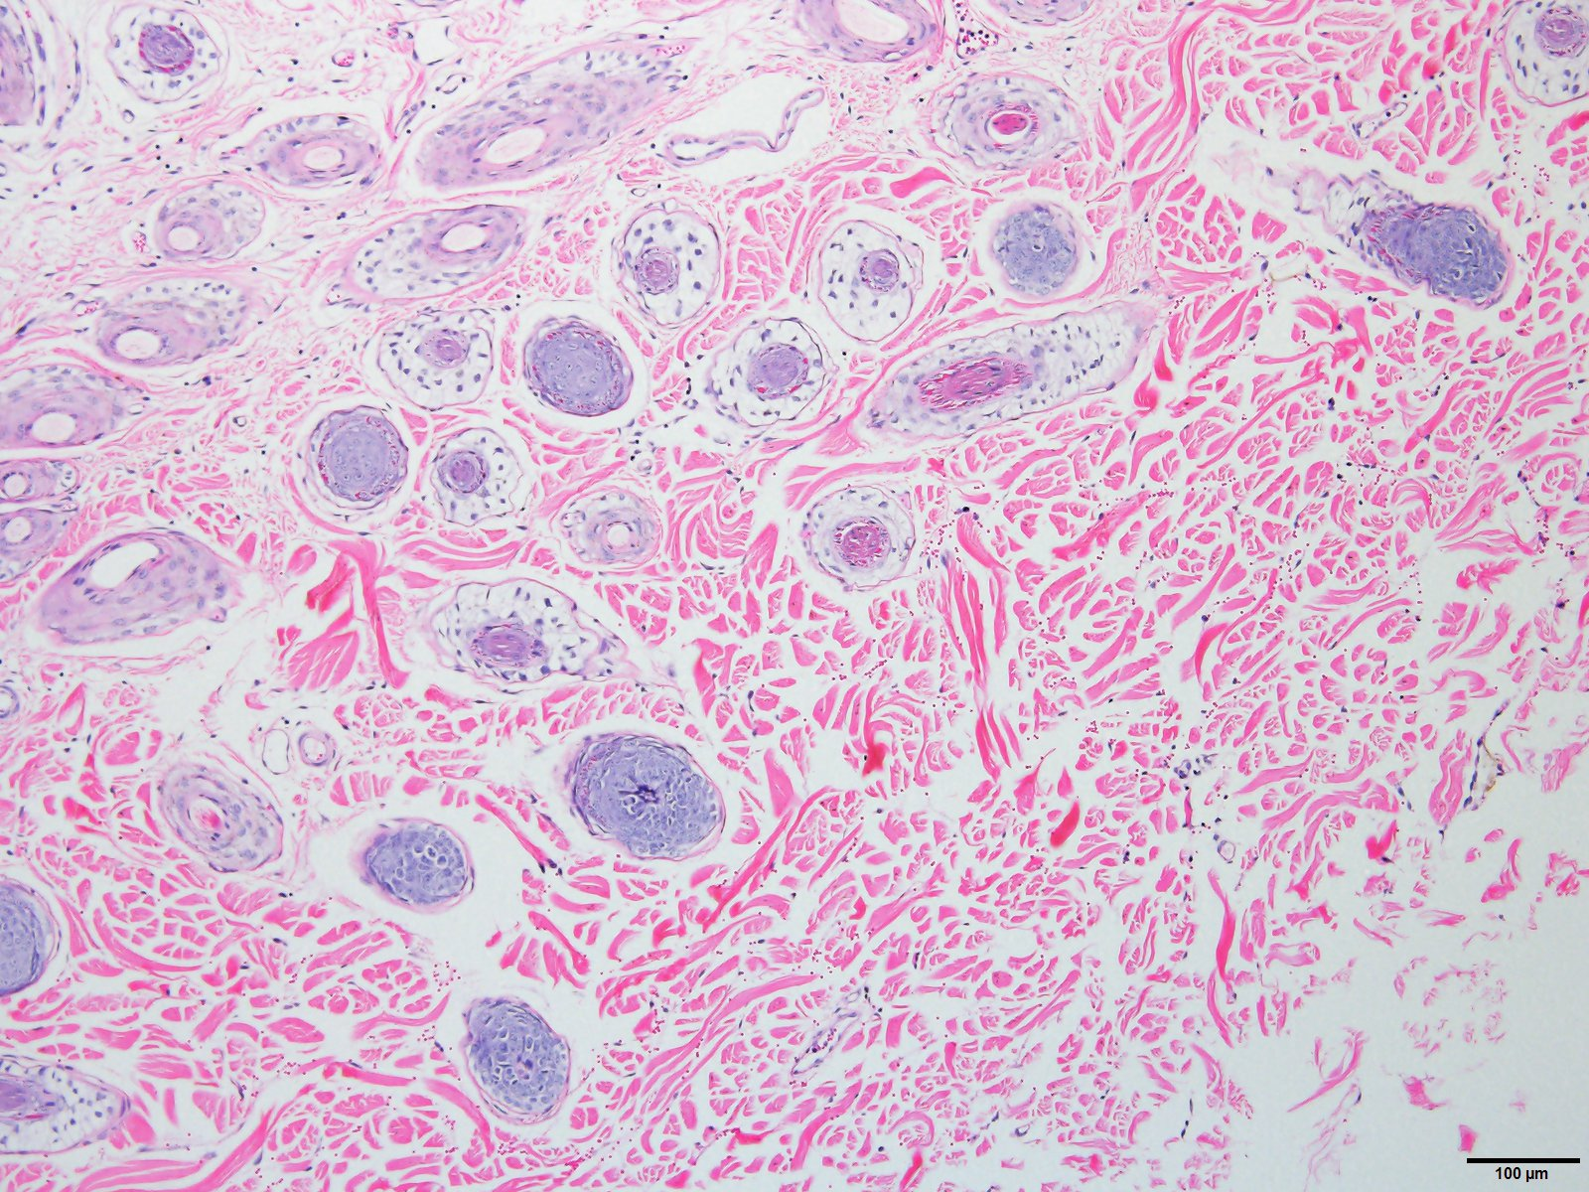

3433 on wrinkle 10 x jpg

(insert loose skin photo here showing no collagen sheets surrounding follicle bulbs)

**Figure 9. ……**(new photos for Figure 9 to be inserted here - Sanaz, could you please send me H & E x 10 photos from Glensloy smooth skins to contrast with Figure 9 photos)

**Collagen type**

PSR photos of above 3 photos here

**Follicle curvature, unevenness and depth**

Results are shown in Table 3.

|  |  |  |  |
| --- | --- | --- | --- |
| Flock | Skin Type | Mean follicle curvature | SD follicle curvature |
| Glensloy | Loose | 1.7 |  |
|  | Wrinkly | 3.8 |  |
| Manton | Loose | 2.7 |  |
|  | Wrinkly | 5.1 |  |

**Fleece and fibre properties**

Results are shown in Table 4.

Table 4. Fleece and fibre differences

|  |  |  |  |  |  |  |
| --- | --- | --- | --- | --- | --- | --- |
| Flock | Skin type | Fibre diameter  (microns) | CV of fibre diameter (%) | Fibre length (mm/day) | CV of fibre length (%) | Staple area (mm2) |
| Glensloy | Loose | 16.6 | 12.1 | 0.56 | 8.0 | 6.7 |
|  | Wrinkly | 18.5 | 15.1 | 0.55 | 10.9 | 25.2 |
| Manton | Loose | 17.2 | 11.7 | 0.48 | 7.7 | 13.1 |
|  | Wrinkly | 18.3 | 16.6 | 0.40 | 14.5 | 27.4 |

Loose skin sheep produced fibres of finer and more uniform diameter than wrinkly skin sheep. The fibres were more uniform in length, and in the case of the Manton flock, longer. The fleece staple were thinner in the loose skin sheep than in the wrinkly skin sheep.

(JW to insert photos of fleece samples and photos Jim Gordon took of clipped areas here).

**Discussion**

Collagen is deposited mainly below the follicles of the papillary dermis. More collagen is present in wrinkly skin sheep than in loose skin sheep. The collagen of wrinkly skin sheep is arranged as thick, enmeshed sheets, which from polarised light images of PSR stained vertical skin sections, appears to consist mainly of Type I collagen (“hard” collagen). On the other hand, the collagen of loose skin sheep is an orderly arrangement (reticular pattern) of thin sheets with a mix of collagen types, including Type III collagen (“soft” collagen).

In wrinkly skin sheep, the thick collagen sheets are also present in large numbers immediately surrounding the follicle bulbs. The follicles are highly curved, and the fibres emerging into the fleece are higher in fibre diameter, more variable in fibre diameter, and more variable in fibre length than in the loose skin sheep. In the loose skin sheep, collagen sheets were not found in the follicular layer, and the follicles were straight rather than curved.

In these studies, it is evident that wrinkle development occurs entirely within the papillary dermis (layer 2). It is the result of excessive, hard collagen being deposited in the subfollicular layer. The process requires high dermal expansion in the follicular layer to allow the wrinkle to rise. Presumably, the greater the amount of hard collagen present, the greater is the uplifting force to form a visible wrinkle.

I am concerned about this sentence. More high dermal expansion means a bigger wrinkle. We dont know what more collagen means, except that we observe that wrinkled sheep have more of it. How about this .. More high dermal expansion over a more rigid high collagen base leads to a bigger wrinkle.

Think about it , we need to say this right. I dont think the collagen pushes up. The reticular dermis goes up inside the wrinkle and that is below the collagen?

And similarly, the more likely there is to be displacement of the follicles bulbs and for the follicles to become highly curved; a proposition which is supported by the high genetic correlation between wrinkle score and follicle curvature (Jackson and Watts, 2017).

The reticular dermis (layer 3) remained supple and low in collagen content, and was not directly involved in wrinkle formation. This layer is usually retained at the base of the wrinkle (see Figure 1). It is possible that as wrinkly sheep age, or more extreme cases of wrinkly sheep are studied, that hard collagen deposition in the reticular dermis may be found and implicated in wrinkle development.

Historically, the term, “fold”, has been used interchangeably with wrinkle, but this may not be anatomically correct. Folds develop from wrinkles when layer 2 separates from layer 3, or layer 2 with layer 3 attached separates from layer 4. In both situations, a space is created at the base of the wrinkle. Dermal expansion creates converging, sideways forces which enlargen the space and lead to folds.

Do we have a photo of a fold with 'space'?

I would like to see this 'separation' . You mean air spaces in the skin?

Might have to wait till someone slaughters a ram to get a sample for this?

The effect of growth of collagen in the dermis on the integrity of the follicle trio group has been known for a long time. Carter (1943) makes the following observation. He is referring to the appearance of trio groups in horizontal skin sections.

“The growth of dermal connective tissue tends to disrupt the earlier, more orderly arrangement, so that the original trio group may be hard to discern. At the same time the linear arrangement of adjacent groups may also be distorted. These changes are more apparent than real, and are due to the rapid increase in absolute size of the group. If a low enough magnification is used, and sufficiently wide areas of skin mapped, it can be seen that, on the whole, the primitive order remains. Connective tissue growth may continue as long as there is a general increase in body size. In some animals it is especially exuberant, resulting in the formation of skin wrinkles and folds. The expansion in area of follicle group, due to this process, is most clearly shown in the decreasing density of the primary follicles as growth continues. “

This phenomenon of disruption of the arrangement of trio groups as seen in horizontal sections was known to Ted Nay (see Nay,1966, and Figure 87 of Maddocks and Jackson,1988) who observed that sheep with tangled or curved follicles tended to have more trio group disruption. This observation links follicle curvature to collagen growth. Nay also noted that the arrangement of the vascular system was different for skins with straight follicles or tangled follicles.

Given the above, it is obvious that sheep of skin type SRS have very little disruption of the arrangement of trio groups, since in an adult horizontal section their trio groups appear in orderly rows, and they also have minimal development of collagen tissue. This is a proposition we have tested with the collagen measurements made in this study.

It is clear that collagen development affects follicle development and function.

We propose two mechanisms:

**The wrinkle – hard collagen – fibroblast numbers – prepapilla cell numbers – follicle density – fibre diameter link**

In skin with wrinkle development, there is more Type I (hard) collagen in the dermal layer (and probably in layer 4 too). Hard collagen requires more mature fibroblasts (because it has more fibres), and hence more fibroblasts must differentiate from the mesenchyme cells. This leaves fewer mesenchyme cells to differentiate into pre-papilla cells. Fewer pre-papilla cells lead to less S follicle initiation, less branched follicles, lower S/P ratio, and higher S fibre diameters.

The reverse situation is where the collagen stays soft (Type III) and in a reticular pattern in the dermis. Wrinkles do not form (because the soft collagen is more elastic and therefore layers 3 and 4 can stay flat. Soft collagen requires fewer fibroblast cells to differentiate (because it has fewer fibres), leaving more capacity for pre-papilla cell differentiation, leading to more S follicles initiated, more branching follicles, higher S/P ratio, and finer S fibres.

So it is a question of balance between collagen development and follicle development. We have no idea what controls the balance. It is undoubtedly genetic. The work of our colleague Dr. Phillip Moore and collaborators (Xavier et al, 2013) and Gordon-Thompson et al (2007) suggests that the Notch pathway genes are implicated.

If this proposed mechanism is correct we expect:

* wrinkled sheep will have either more collagen or harder collagen or both in the dermal layer
* sheep with more or harder collagen will have lower pre-papilla cell numbers, with consequent lower S/P ratio
* sheep with more or harder collagen may have a secondary fibre diameter. This would be an indirect, as a consequence of forming less branching follicles.

These expectations can be tested. We do that by measuring collagen amount and softness in the dermal layer of skin specimens, and relating it to wrinkle, S/P ratio, and diameter of secondary fibres.

**The wrinkle – hard collagen – curved follicles – curved fibres link**

In skin with wrinkle development, there is more hard collagen in the dermis. The downgrowths of epithelial tissue which forms developing follicles have to penetrate and displace the dermal tissue. If the dermis has hard, intermeshed collagen, the follicle downgrowths can not readily penetrate the dermis to full depth, so they grow in a curved shape and the bulbs are closer to the epidermis. The orientation of the plane of curvature would depend on spatial considerations. Curved follicles grow curved fibres, with a greater proportion of paracortex, and a more highly keratinised paracortex.

Fibre growth is a question of the way the bulb cells differentiate to form the fibre cortex in straight versus curved follicles. In curved follicles there is more bilateral asymmetry in the fibre cortex. If there is more keratinisation it means bulb cell differentiation into fibre proceeds for longer, so the fibre length growth rate would be slower. There may also be differences in blood vessel supply to follicles between skins with curved and straight follicles (Nay,1966). Collagen development and blood vessel development may therefore interact. If this proposition is correct we expect:

* wrinkled sheep to have more or harder collagen in the dermal layer (as in proposition 1)
* sheep with more or harder collagen to have curved follicles
* sheep with curved follicles to grow curved fibres, with a more radical ortho/para segmentation
* sheep with curved follicles to have lower fibre length growth rate
* sheep with curved follicles may have a higher secondary fibre diameter
* sheep with more or harder collagen may have follicles of uneven depth
* sheep with follicles of uneven depth may have greater variability of secondary fibre diameter.

These expectations can also be tested. We already know that the genetic correlation of wrinkle score with crimp frequency is 0.46 (95 percent confidence limits 0.40 to 0.51), and the genetic correlation of wrinkle score with follicle curvature is 0.69 (95 percent confidence limits 0.65-0.74 (Jackson 2017). These strong correlations are an overall confirmation, but do not prove that collagen is the linking factor. In the present study we have collagen measurements and we have follicle curvature scores, so testing the above expectations can be done.

It is also clear that a certain amount of follicle development ( as in Merino sheep) is an important factor predisposing sheep to wrinkle formation. We propose one further mechanism :

**The skinspace hypothesis**

**Or maybe the dermal expansion hypothesis**

**You decide**

In Merino sheep there is an enormous development of branched secondary follicles in the foetal stage at around 85 to 150 days. One can calculate that this expands the follicular dermis by 15 to 30 percent, over and above the other skin layers (Jackson and Watts (2018)). This is probably the source of what is referred to here as 'high dermal expansion', and it is an important presisposing factor in wrinkle formation.

Sheep without this branched secondary follicle development ( eg non-Merino breeds) do not develop wrinkles, even their skin has high collagen content.

Understanding high dermal expansion is the key to unravelling the mystery of wrinkle formation. It is the difference in growth between layers of the skin that causes certain layers to go up into a fold. The role of collagen may be to hold some layers rigid, and it may also cause actual shrinkage of some layers. It is clear from the effect on follicle curvature that collagen fibrils move things around, so they may attach to surrounding tissues including follicles, and shrink in length as they develop.

The alternative to explain movement of follicles is that collagen development may push the follicles around, simply by taking up dermal space. If this is the case, collagen development would also contribute to dermal expansion, over and above the branching follicle contribution.

To answer this question, we have to work out when and how wrinkle development impacts on the type of follicle development process which leads to SRS sheep.

This sentence does not fit in. How about the following

There is more to SRS sheep than an absence of wrinkles and a reduced development of collagen. They were originally developed by selection of sheep with loose skin, thin staples, low crimp, and soft lustrous wool, in addition to absence of wrinkle. They also have considerably higher numbers of secondary derived follicles than other Merino strains, and there has been some progress in our understanding of the development process which leads to this increase in follicle numbers.

We know something about the SRS development process.

Then leave out this bit above, and carry on...

The pre-papilla cell

model of Moore et al (1989) and Moore et al (1998) explains why suppression of the size of primary follicles (and therefore suppression of the primary fibre diameter), leads to vastly greater numbers of secondary derived follicles formed as branches to primary and secondary original follicles, leading to compound follicles. What we understand far less, is why these larger compound follicles grow such a different fibre that is fine, long, low crimped, soft, and lustrous. We also know

something about why these fibres form thinner fleece staples with a different type of

staple crimp (Jackson and Watts, 2016).

We also now know something about why SRS sheep dont form wrinkles, even though the high follicle numbers predispose them to wrinkle formation. They avoid it by disconnecting the skin layers so that the differences in growth between layers do not lead to folding. That is the magic of loose skin, it implies reduced collagen, less inter-layer connectivity, and no folding.

(JW to report that Merino breeders may be confusing looseness of the skin with the free movement of layer 3 over layer 4 when it is the looseness and suppleness of the follicular and subfollicular layers of the papillary dermis, which generate sideways movement and lift when palpated, that is important in identifying sheep without the problem of excessive collagen deposition and follicle disruption).

**Acknowledgements**

**References**

Belschner, H.G. and Seddon, H.R. (1937). The classification according to susceptibility to breech strike. Scientific Bulletin of the Department of Agriculture of New South Wales, **54**: 111-122.

Belschner, H.G. Carter, H.B. and Helen Newton Turner (1937a). “Fleece characteristics of stud Merino sheep in relation to the degree of wrinkliness of the skin of the breech”. *Aust. Vet. J.* pp. 16 -28.

Bogolyubsky, S.N. (1940) cited by Fraser A.S. and Short B.F. (1960). The Biology of the Fleece. Animal Research Laboratories Technical Paper No. #. CSIRO Melbourne 1960.

Carter, H.B. (1943) Studies in the biology of the skin and fleece of sheep. 1. The development and general histology of the follicle group in the skin of the Merino. 2. The use of tanned sheepskin in the study of follicle population density. 3. Notes on the arrangement, nomenclature, and variation of skin folds and wrinkles in the Merino. C.S.I.R. Bulletin No. 164, Melbourne, 1943.

Drinan, J.P. and Dun, R.B. (1965). Skin folds and Merino breeding. 3. The association between skin fold and the productivity of Merino ewes in fourteen New South Wales flocks. *Aust. J. exp. Agric. Anim. Husb.* 5 (19), 345-3

Dun, R.B. (1964). Skin folds and Merino breeding. 1. The net reproductive rates of flocks selected for and against skin fold. *Aust. J. Agric. exp. Agric. Anim. Husb.* 4:376-385

Dun, R.B. and Hamilton, B.A. (1965). Skin folds and Merino breeding. 2. The relative influence of the ram and the ewe on fertility and perinatal lamb mortality in flocks selected for and against skin fold. *Aust. J. exp. Agric. Anim. Husb.* 5 (18), 236 – 242.

Gordon-Thompson, C., Botto, S.A., Cam, G.R. and Moore, G.P. H. (2008). Notch gene pathway expression and wool follicle cell fates. Aust. J. Exp. Agric. 48 (5) 648-656.

Jackson, N., Nay, T, and Turner, Helen Newton (1975). Response to selection in Australian Merino sheep. VII Phenotypic and genetic parameters for some wool characteristics and their correlation with wool and body traits. Aust. J. Agric. Res. 26:937-57.

Jackson, N. (2017). Genetics of primary and secondary fibre diameters and densities in Merino sheep. URL <https://github.com/nevillejackson/atavistic-sheep/mev-rewrite/supplementary/genetic-parameters/psparam.pdf>

Jackson, N. (2017). Genetic relationship between skin and wool traits in Merino sheep. Part I Responses to selection and estimates of genetic parameters. URL <http://github.com/nevillejackson/Fleece>genetics/tree/master/skinandfleeceparameters/ab3220/skinwool1.pdf

Jackson, N. and Watts, J.E. (2017). What is known about the genetics of wrinkle score in Merino sheep ? URL <http://github.com/nevillejackson/Fleece-genetics/wrinkle/wrinkle.pdf>

Jones, J.M., B. L. Warwick, R.W. Phillips, D.A. Spencer, C.B. Godbey, R.E. Patterson and W.H. Dameron (1946).  Inheritance of skin folds of sheep.  *J. Anim. Sci.* **5:**164-169.

Jones, J.M., W.H. Dameron, S.P. Davis, B.L. Warwick and R.E. Patterson. Influence of age, type and fertility in Rambouillet ewes on fineness of fiber, fleece weight, staple length and body weight. Texas Agr. Expt. Sta. Bul. 6571944

Knight, K.R., Lepore, D.A., Horne, R.S., Ritz, M., Kumta, S. and O’Brian, B.M. (1993). Collagen content of uninjured skin and scar tissue in foetal and adult sheep. Int, J. Exp. Pathol. 74 (6):583-591.

Menton, D.N. and Hess, R.A. (1980). The ultrastructure of collagen in the dermis of tight skin (Tsk) mutant mice. The Journal of Investigative Dermatology 74:139-147.

Mitchell, T.W., Ann Nieass, Rigby, B.J. and Snaith, J.W. (1984). Some physical and mechanical properties of sheep skin with a comparison of “thick” and “thin” skins. Wool Technology and Sheep Breeding. 22(4), 200-206.

Moore, G.P.M. (1984). Growth and development of follicle populations and critical stages of growth. Proceedings of a seminar on wool production in Western Australia. (Ed. S.K. Baker, D.G. Masters and I.H. Williams). Australian Society of Animal Production (W.A. branch).

Moore, G.P.M., Jackson, N. and Lax, J. (1989). Evodence of a unique developmental mechanism specifying both wool follicle density and fibre size in sheep selected for single skin and fleece characteristics. Genet. Res. Camb. **53**, 57-62.

Moore, G.P.M., Jackson, N., Isaacs, K. and Brown, G. (1998). Pattern and morphogenesis in skin. J. theor. Biol. **191**, 87-94.

Nay, T. (1966). Wool follicle arrangement and vascular pattern in the Australian Merino. Aust. J. Agric. Res. 17: 797-805.

Nay, T. (1973). Wool follicles – A manual for breeders. Australian Wool Corporation, Melbourne.

Randall, Henry S. (1863). Fine Wool sheep husbandry. C. M. Saxton, N.Y.

Turner, Helen Newton, Hayman, R.H., Riches, J.H., Roberts, N.F., and

Wilson, L.T. (1953) Physical definition of sheep and their fleece for breeding

and husbandry studies: with particular reference to Merino sheep. CSIRO

Div. Anim. Hlth. Prod. Div. Rept. No. 4 (Ser SW-2 mimeo)

Turner, Helen Newton (1956) Anim. Breed. Abstr. 24: 87-118.

Turner, Helen Newton (1958) Aust. J. Agric. Res. 9: 521 -52.

Turner, Helen Newton, Brooker M.G. and Dolling, C.H.S. (1970). Response to selection in Australian Merino sheep. III. Single character selection for high and low values of wool weight and its components. Aust. J. Agric. Res. 21: 955-84.

Watts, J.E. (2008a). Breeding mules-free Merinos within five years. Australian Farm Journal. pp.45-47.

Watts, J.E. (2008b). Fly strike resistance. Non-mulesed Merinos within 5 years. Australian Farm Journal. pp. 52-55.

Watts, J.E. (2016). No mulesing and no fly strike. In Redesigning Animal and Fibre Genetics in Merinos, Angoras and Alpacas. Your guide to the science behind SRS® breeding and selection. Edited by Patrick Francis, August 2014, pp.29-30.

Watts, J.E., Jackson, N. and Ferguson, K.A. (2017). Improvements in fleece weight and wool quality of Merino sheep selected visually for high fibre density and length. URL[https://github.com/nevillejackson/SRSMerino/Paper](https://github.com/nevillejackson/SRS-Merino/Paper).2.Revised.10.November.2017.docx

Xavier, S.P., Gordon-Thomson, C., Wynn, P.C., McCullagh, P.,Thomson, P.C., Tomkins, L., Mason, R.S., and Moore, G.P.M. (2003). Evidence that Notch and Delta expressions have a role in Dermal condensate aggregation during wool follicle initiation. Experimental Dermatology, 22: 656-681.

Jackson, N. and Watts, J.E. (2018) Does follicle development affect the spatial layout of sheep skin. URL https://github.com/nevillejackson/Fleece-biology/tree/master/skinspace/skinspace.pdf